ASTA 607: STATISTISCAL COMPUTING
ID: 22424238
Question 1
- The crabs dataset is a morphological measurements on leptograpsus crabs. The crabs data frame has 200 rows and 8 columns, describing 5 morphological measurements on 50 crabs each of two colour forms and both sexes, of the species Leptograpsus variegatus
data(crabs)
head(crabs)
str(crabs)

freq_species<-table(crabs$sp,crabs$sex)

barplot(freq_species, beside=TRUE, legend=TRUE, col=c("turquoise","pink"), xlab="Species", ylab="Frequency", main="A Bar Chart of Species and sex")

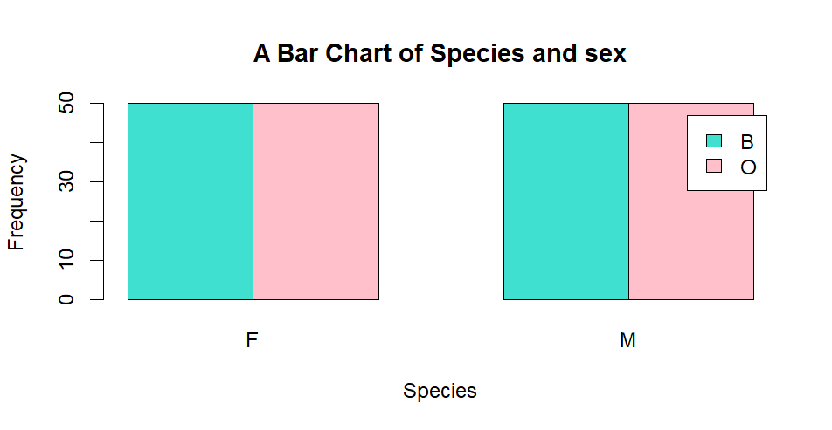
The data is balanced across the four groups because their frequencies are the same hence good comparisons can be considered to reduce bias.

QUESTION 2
boxplot(crabs$BD ~ crabs$sp + crabs$sex, xlab="Species and Sex", ylab="Body Depth", main="Boxplots of Body Depth by Species and Sex",col=3:6)

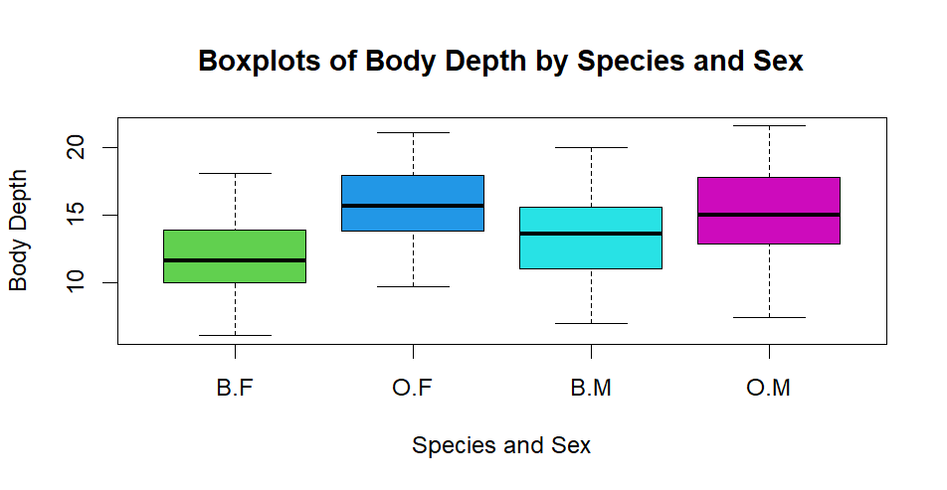
- There are no outliers in the data and the distributions are slightly symmetric.

Question 3
par(mfrow=c(1,2))
# Histogram for species 1
hist(crabs$CL[crabs$sp == "B"], main="A Histogram of Carapace Length for Species B", xlab="Carapace Length", col="blue", border="black")
# Histogram for species 2
hist(crabs$CL[crabs$sp == "O"], main="A Histogram of Carapace Length for Species O", xlab="Carapace Length", col="wheat", border="black")

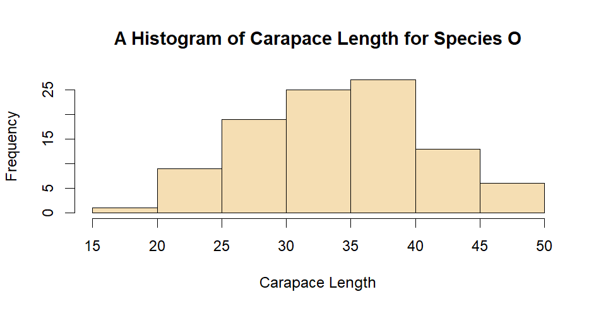
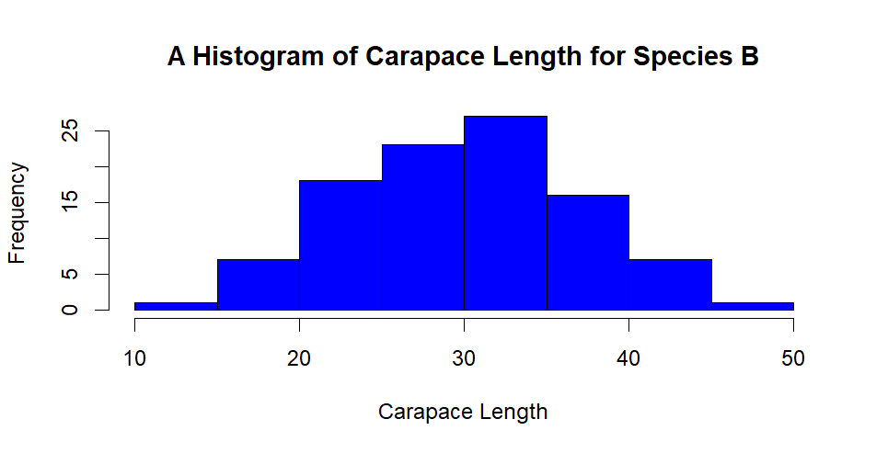
- The histogram for species B appears to be slightly right-skewed, with a longer tail on the right side. This suggests that there are more crabs with smaller carapace lengths and fewer crabs with larger carapace lengths. The distribution is unimodal, with a single peak around the lower carapace lengths whiles the histogram for species O appears to be more symmetric, with a more balanced distribution of carapace lengths. It also appears to be unimodal, with a single peak around the middle carapace lengths. There is less skewness in this distribution compared to species B meaning that the spread of carapace lengths among the crabs in species O are even.

Question 4
a.
library(dplyr)
crabs%>%
group_by(sp) %>%
summarise(mean_CL = mean(CL),
mean_CW = mean(CW),
mean_FL = mean(FL),
mean_RW = mean(RW),
mean_BD = mean(BD))
mean_morphologica_sex<-crabs%>%
group_by(sex) %>%
summarise(mean_CL = mean(CL), mean_CW = mean(CW), mean_FL = mean(FL),
mean_RW = mean(RW),
mean_BD = mean(BD))

b.

barplot(as.matrix(mean_morphological[,-1]), beside=TRUE, legend=TRUE, col=c("green","honeydew1"), xlab="Morphological measurements", ylab="Mean", main="A Grouped Bar Chart of Mean Morphological Measurements", names.arg=c("CL","CW","FL","RW","BD"))
#barplot for mean by sex
barplot(as.matrix(mean_morphologica_sex[,-1]), beside=TRUE, legend=TRUE, col=c("slateblue1","skyblue"), xlab="Morphological measurements", ylab="Mean", main="A Grouped Bar Chart of Mean Morphological Measurements", names.arg=c("CL","CW","FL","RW","BD"))

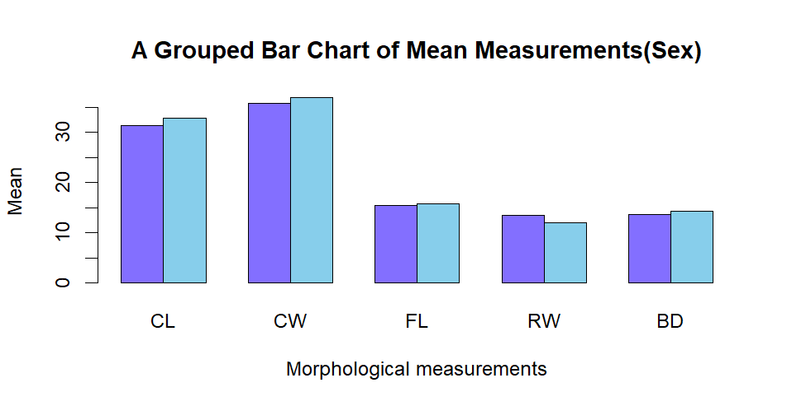

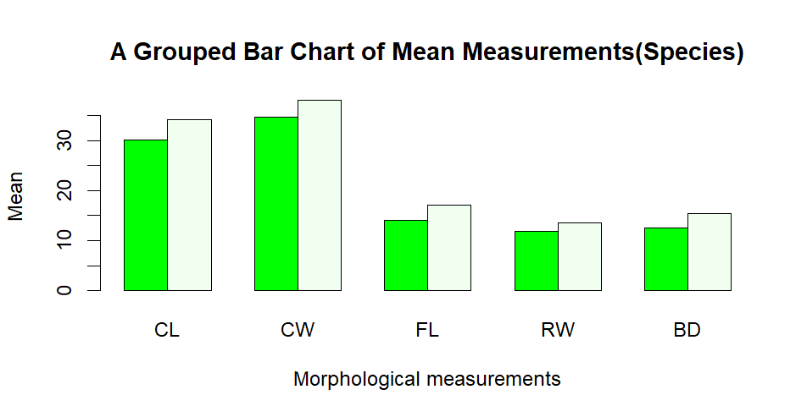

- From the diagrams, CW measurement of shows the greatest species difference whiles the RW measurement has the least sex variation.

Question 5
pairs(crabs[,4:8], main="Scatterplot Matrix of Morphological Measurements", pch=19, col="peachpuff3")

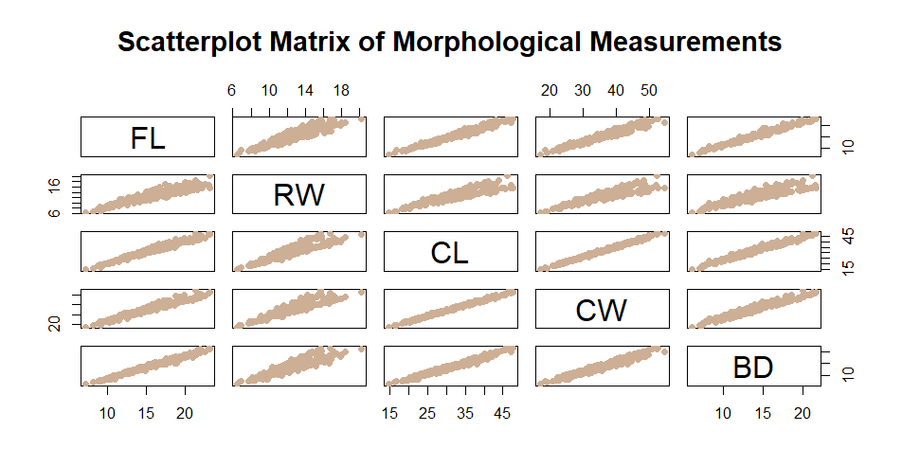
- There are positive relationships among all the variables, meaning they increase together. Carapace length (CL), carapace width (CW), and frontal lobe length (FL) have strong positive correlations. Rear width (RW) has moderate positive relationships with the main measurements. Body depth (BD) of the leptograpsus crab shows weak positive correlations with all other variables and there is also a slight tendency for body depth to increase as frontal lobe length increases, but the relationship is not very strong. RW and BD show a weak positive correlation, suggesting that there is a slight tendency for body depth to increase as rear width increases, but the relationship is not very strong.

Question 6
The analysis of the crabs dataset revealed clear differences in species and sex composition as well as morphological characteristics. The frequency table showed that species B had 50 males and 50 females, while species O had 50 males and 50 females, indicating an even or balanced distribution across groups.
Side-by-side boxplots of body depth (BD) showed that species B had slightly higher median BD around 6.1 mm for males and 5.5 mm for females compared to species O 5.9 mm for males and 5.2 mm for females highlighting differences between species and sexes.
Histograms of carapace length (CL) indicated that species B had a mean CL of 5.9 mm, while species O had a mean CL of 6.2 mm.
Grouped bar charts of mean morphological measurements showed that species B had average CW = 6.7, FL = 4.4, RW = 3.1, BD = 5.8, and species O had CW = 7.3, FL = 4.9, RW = 3.4, BD = 5.5. Comparisons by sex showed males were generally larger than female. Finally, the scatterplot matrix revealed positive correlations among all morphological variables, indicating that crabs larger in one dimension tend to be larger in others. Overall, the analysis demonstrates that both species and sex significantly influence the size and shape of crabs in this dataset. There are positive relationships among all the variables, meaning they increase together. Carapace length, carapace width, and frontal lobe length have strong positive correlations. Rear width has moderate positive relationships with the main measurements. Body depth of the leptograpsus crab shows weak positive correlations with all other variables and there is also a slight tendency for body depth to increase as frontal lobe length increases, but the relationship is not very strong. RW and BD show a weak positive correlation suggesting that there is a slight tendency for body depth to increase as rear width increases but the relationship is not very strong.

